Critical Patch Installation

CPS16

**Version V 1.0**

**Author**

Mansi Nikam

Associate IT Consultant

|  |
| --- |
| **Document Control** |

**Document History**

|  |  |  |  |
| --- | --- | --- | --- |
| **Issue** | **Date** | **Maintainer / Owner** | **Description** |
| 1.0 | 12/11/2019 | Mansi Nikam |  |
|  |  |  |  |
|  |  |  |  |
|  |  |  |  |
|  |  |  |  |

**Review**

|  |  |
| --- | --- |
| **Name** | **Role** |
| Rajvina Yakub | Lead Consultant |
|  |  |
|  |  |

**Approval History**

|  |  |  |
| --- | --- | --- |
| **Approver** | **Approval Date** | **Comments** |
|  |  |  |
|  |  |  |

Table of Contents

[1. Backups 4](#_Toc24459013)

[2. Run setup 5](#_Toc24459014)

[3. Check Windchill Version 13](#_Toc24459015)

[4. Start Windchill 14](#_Toc24459016)

# Backups

Before starting the patch installation, take the following backups:

1. Windchill Folder
2. Database
3. LDAP backup

Navigate to the below location. Run control-panel.bat.

Machine generated alternative text:
r-r¯r- 
computer DATA 
PTC 
• Windchill 
Organize 
Favorites 
z 
Deskh:p 
Downloads 
Recent Places 
Libraries 
Documents 
Print New Folder 
Name 
backup 
base64 
control-panel 
dbtest 
dsconfig 
dsframenork 
Il.x • WindchillD5 • server • ba 
Date modified 
811312015 11 
811312015 11 
811312015 11 
811312015 11 
811312015 11 
811312015 11 
AM 
AM 
AM 
AM 
AM 
AM 
Windows Batch File 
Windows Batch File 
Windows Batch File 
Windows Batch File 
Windows Batch File 
Windows Batch File 

Login with ldap paddword (ldapadmin)

Machine generated alternative text:
Z PTC Windchill Directory Server Control Panel 
Select the server that you want to administer: 
- Ser... 
r-r¯r- 
Local Server 
Instance Path: 
Bind DN: 
Password: 
E: XPTQWindchiII_I I 
cn=Manager 

Machine generated alternative text:
a PTC Windchill Directory Server Control Panel 
r-r¯r- 
File View Help 
Directory Data 
Manage Entries 
New Base DN.. 
Import LDIF.. 
Export LDIF... 
Backup... 
Restore.. 
Schema 
Indexes 
Monitoring 
Runtime Options 
Server Status 
Server Status: 
Started 
Open Connections: 20 
Server Details 
Host Name: 
Administrative Users: 
Installation Path: 
Version: 
Java Version: 
Administration Connector. 
Connection Handlers 
Address:Port 
plm-qa. csl.local 
cn=Manager 
E: XPTQWindchiII_I I 
PTC Windchill Directory Server 2.6.O-8uiId_007 
• Port 4444 (LDAP5) 
Protocol 
0.0.0.0:8080 
Data Sources 
Base DN 
LDIF 
LDAP 
L DAPS 
Backend ID 
userRoot 
Entries 
Disabled 
Enabled 
Disabled 
Enabled 
Disabled 
Replication 

Give the name for the backup file

Machine generated alternative text:
Z PTC Windchill Directory Server Control Panel 
- Export LDIF 
Backend: 
Export to File: 
Export Options: 
userRoot 
E: ibackup\LDAP _backup\LDAP _backup_OSI 1201 g. IdiF 
r-r¯r- I 
Browse... 
r 
IF File exists, overwrite contents OF File instead OF appending. 
Launch non 
Change... 
r 
Compress Data 
r 
Wrap Text at Column 
Data Exclusion Options 
pata ppCiop$ 

# Run setup

Go to the installation directory of CPS16 (E:\QA\_Staging2\PTC Windchill 11.0 Service Pack - Critical Patch Sets Bundles\CPS16\ptc\_solution\_installer\_11.0)

Run the setup.vbs from PSI ssss.

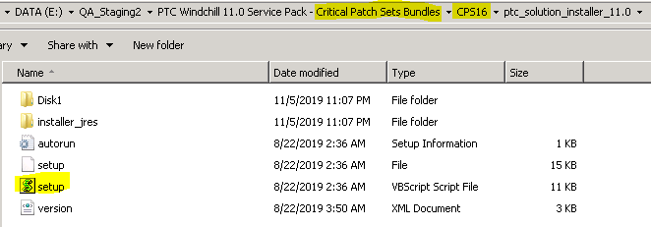

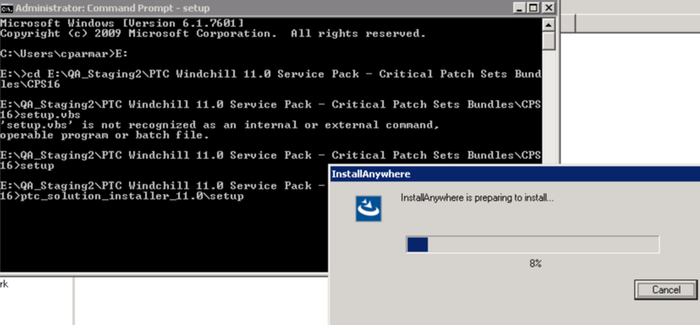

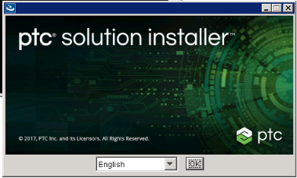

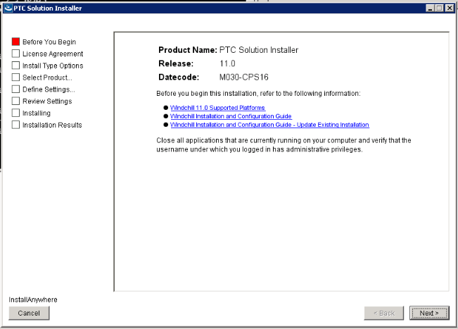

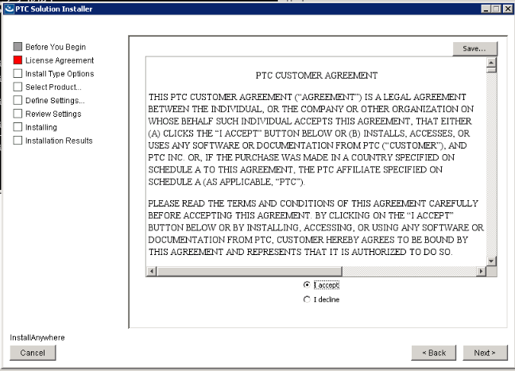

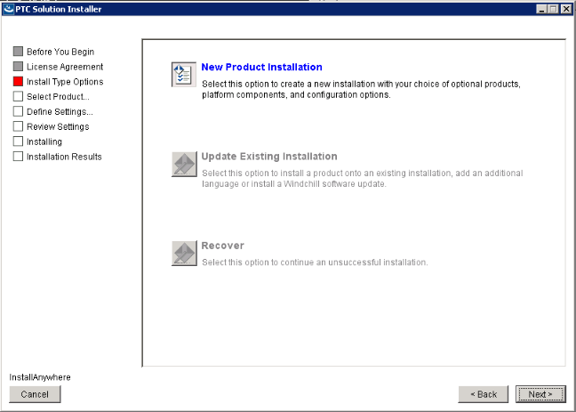

update option is not available because the installation was done by another user.

To get this resolved, find the psi\_iir\_index.

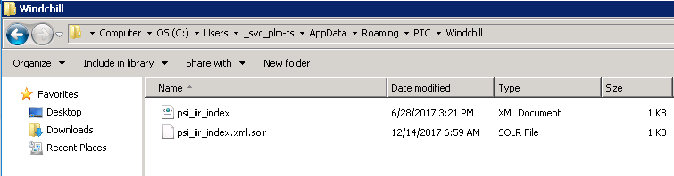

<Instance location="E:\ptc\Windchill\_11.x\PSI" id="ii-fa6103b.15cf026424a.-8000"/>

Copy the file and paste it in below location of our user:

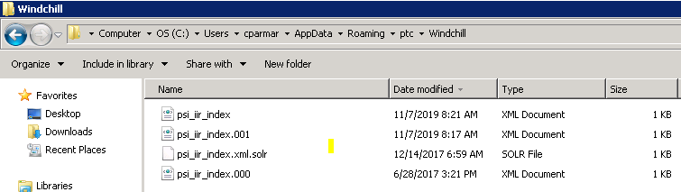

This will make the update option available

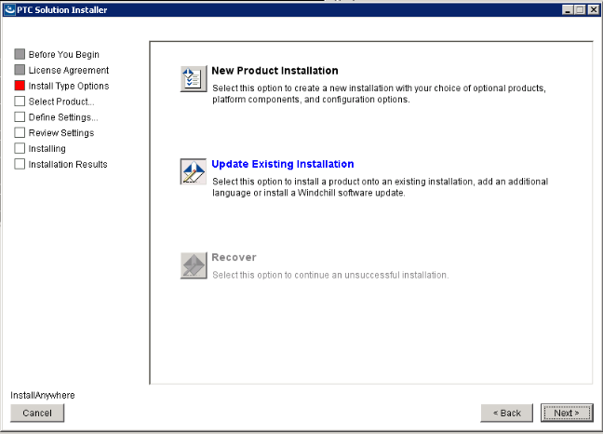

ss

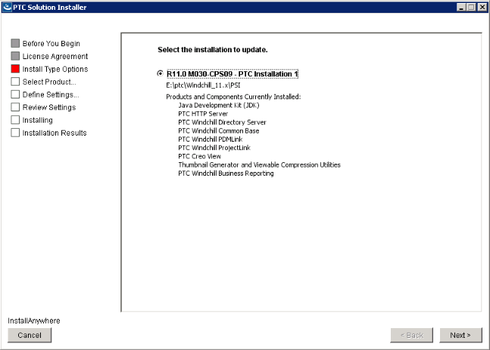

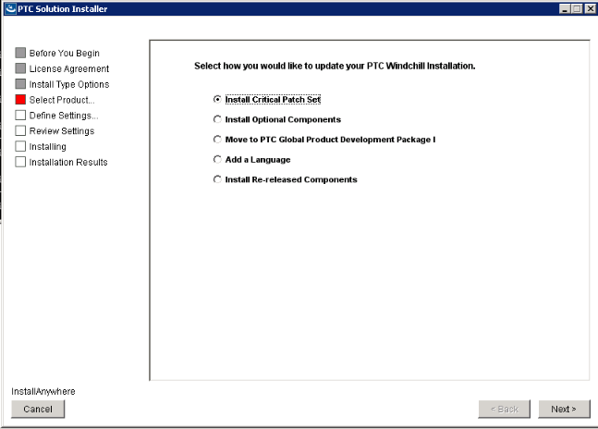

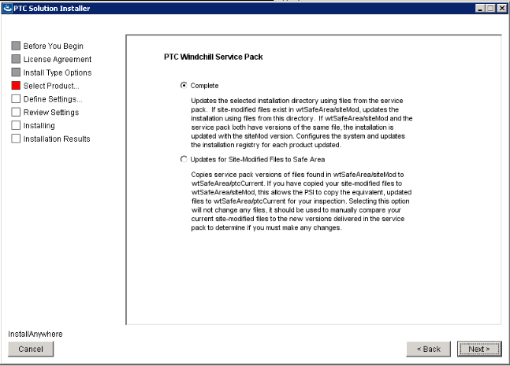

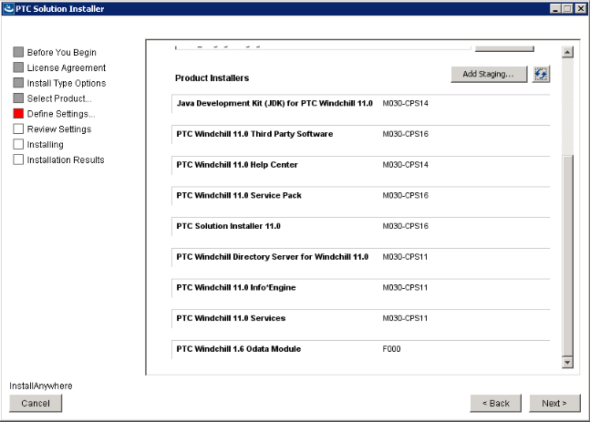

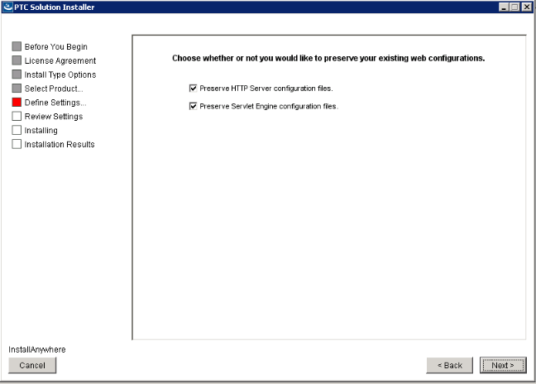

If option to Preserve HTTP Server configuration files is NOT SELECTED during CPS or MOR update process

* The update will apply the fixes for this issue
* Then No additional actions are necessary

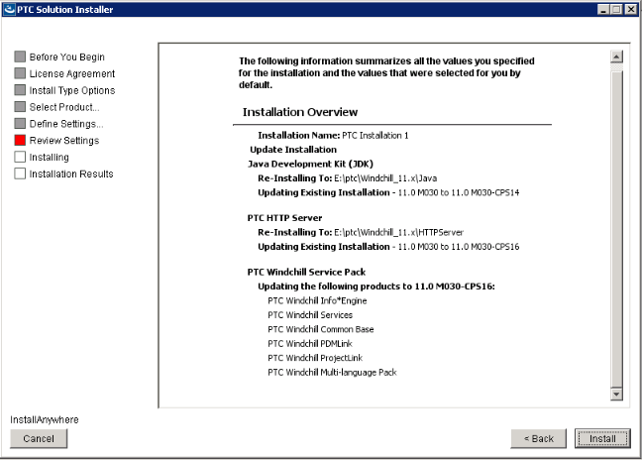

**Error:**

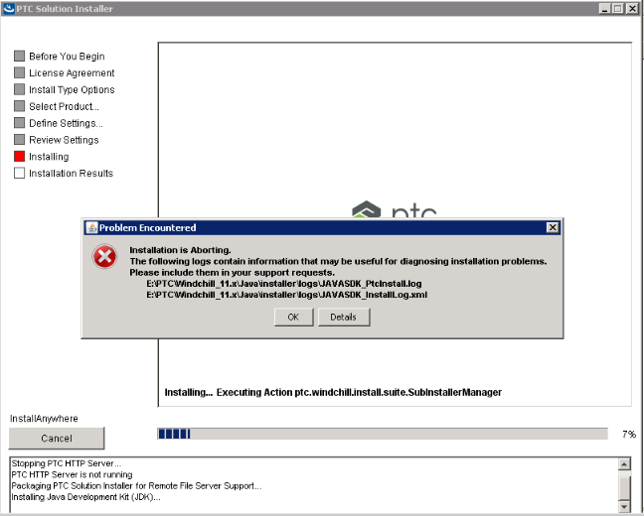

In PTC Install log, below error occurred:

BUILD FAILED

E:\QA\_Staging2\PTC Windchill 11.0 Service Pack - Critical Patch Sets Bundles\CPS16\Java\_development\_kit\_(JDK)\_for\_windchill\_11.0\Disk1\InstallerData\javasdk\uninstall.xml:8: Unable to delete file E:\ptc\Windchill\_11.x\Java\jre\bin\awt.dll

Try renaming the Java Folder and replace the backup\_Java folder to this location.

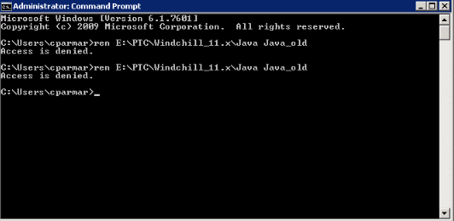

Access Denied.

Take a restart of the server.

This would solve this issue.

Re-run the PSI.

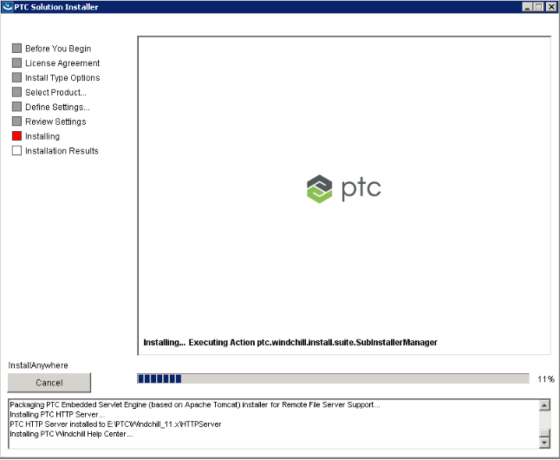

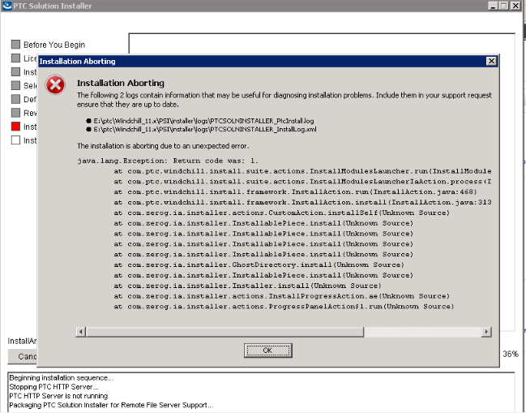

**Error:**

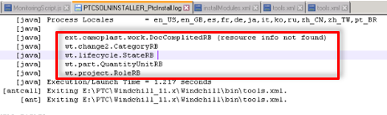

In InstallModules.xml line 1050

<ant antfile="${installroot}/bin/tools.xml" target="bundle\_custom">

In tools.xml line 541

<antcall target="bundle" inheritAll="false">

In tools.xml line 604

<path refid="sysgen.class.path"/>

Invalid resource bundles exist.

**FIX:**

**Article - CS240770**

Move the resource bundles from Windchill/wtCustom/wt reported as **resource not found**.

Re-run the PSI.

After the CPS is run, replace these files in their respective destinations.

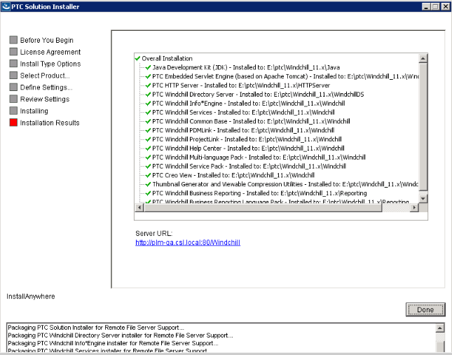

After the successful completion, replace the resource bundle files removed to their respective locations:

Windchill/ wtCustom/ext/camoplast/work/DocComplitedRB

# Check Windchill Version

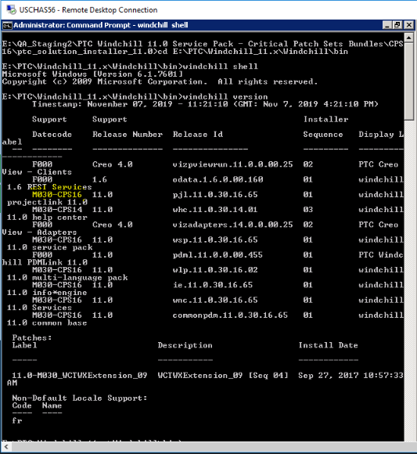

Patch has been updated.

# Start Windchill

**Error:**

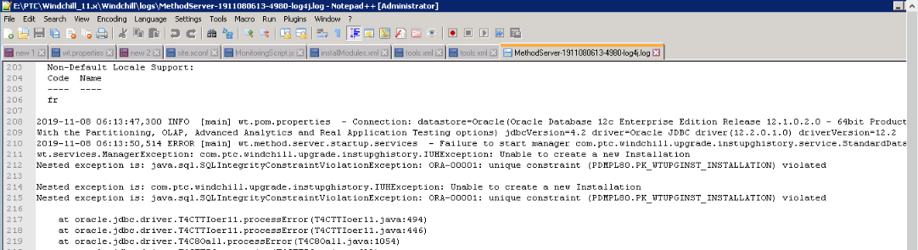

**FIX:**

**Article - CS244368**

Stop windchill server.

Connect to the QA database and run the below commands:

**create table WTUPGINST\_INSTALLATION\_bkp as select \* from WTUPGINST\_INSTALLATION;**

Update the value of column ISUPGRADEMANAGERENTRY of table WTUPGINST\_INSTALLATION to 1 by executing following query:

**update WTUPGINST\_INSTALLATION set ISUPGRADEMANAGERENTRY=1 where id=<enter the current id of Windchill version>;**

**Commit;**

Clear Cache and start Windchill.

While authentication, recieved below error:

**503 Service Unavailable**

Unable to start HTTP sever

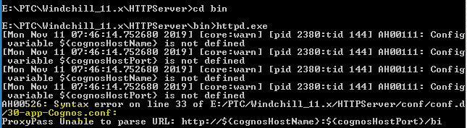

Remove the query block (line 33) from the file 30-app-Cognos.conf.  
Restart HTTP Server.

**HTTP 404 Error:**

Compare the web.xml from current folder and the backup folder.

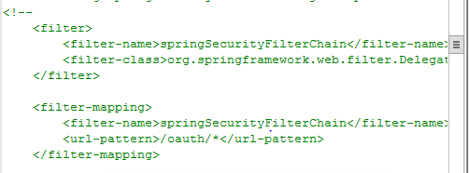

The above block was commented out in the backup folder.  
This block was commented.  
Windchill was started successfully.

In server **status, master status** was “Servlet Engine Not Responding”

This error is faced because the option “Preserve HTTP Server Configuration Files” was selected during CPS installation

**FIX:**

**Article - CS306977**

1. Stop HTTPServer
2. Merge the contents of <HTTPSERVER\_HOME>/conf-BACKUP into <HTTPSERVER\_HOME>/conf directory

Upon comparing the workers.properties from conf-BACKUP and conf, the below entry need to be propagated:

**worker.ajpWorker.lb\_retries=9** in in conf/workersProperties.xml

**<xsl:param name="lbRetries" select='9'/>** in conf\templates\xsl\ workersProperties.xml

1. Open Windchill Shell and navigate to <HTTPSERVER\_HOME> directory
2. Run the following command(s):
   * If there are updates in both
     + ant -f config.xml reconfigure
     + ant -f webAppConfig.xml regenAllWebApps
3. Start HTTPServer
4. Verification

* Line worker.ajpWorker.lb\_retries=9 will be added to <HTTPSERVER\_HOME>/conf/workers.properties after running ant commands
* Following contents should be merged into <HTTPSERVER\_HOME>/conf/templates/xsl/workersProperties.xsl

<xsl:param name="lbRetries" select='9'/>  
  
worker.<xsl:value-of select='$ajpWorker'/>.lb\_retries=<xsl:value-of select='$lbRetries'/>

Windchill is started.

